



S.K.P ENGINEERING COLLEGE

Approved by AICTE & Affiliated to Anna University

NH 66, Somasipadi Post,Chinnakangiyanur, Tiruvannamalai,

Tamil Nadu-606611

**DEPARTMENT OF COMPUTER SCIENCE AND**

**ENGINEERING**

BACHELOR OF ENGINEERING 2024-2025

FIFTH SEMESTER

**PROJECT TITLE: A CRM Application to Handle the Clients and their property Related Requirements**

**Project Created by:** Sharveshvaran.N, Shamrintaj.B, Srikanth.R, Sathish.K

**Project Reviewed by:** Dr.M.Senthil (AP/CSE)

**College Code:** 5122

**Team ID** : NM2024TMID09254





 S.K.P ENGINEERING COLLEGE

Approved by AICTE & Affiliated to Anna University

**DEPARTMENT OF COMPUTER SCIENCE AND**

**ENGINEERING**

Certified that this is a bonafide record of work done by

Name : Sharveshvaran.N, Shamrintaj.B, Srikanth.R, Sathish.K

University Reg No :

Year / Semester : 3 / 5

Branch : CSE

Year : 2024-2025

## Staff-in-Charge Head of the Department

Submitted for the Practical Examination held on

**Internal Examiner External Examiner**





**A CRM Application to Handle the Clients and their property Related Requirements**

#### PROJECT VIEW:

#### This project is focused on developing a CRM application to handle clients and their property-related requirements, designed to address the challenges of managing client interactions and property details efficiently. The goal is to deliver a comprehensive solution by leveraging Salesforce CRM and advanced data analytics. Through this project, we aim to enhance operational efficiency, user experience, and data accuracy, supporting the long-term goals of real estate businesses and property management organizations.

# OBJECTIVES:

# Business Goals

# Increase Client Retention: Improve client satisfaction and retention by 25% within the first year of implementation through better management of client interactions and property details.

# Boost Sales Efficiency: Achieve a 30% increase in sales efficiency by automating client follow-ups, property showings, and deal closures.

# Enhance Data Management: Ensure 95% data accuracy and consistency across all client and property records by leveraging a centralized CRM system.

# Expand Market Reach: Increase market reach by 20% within the first year by utilizing data analytics to identify and target new client segments and property opportunities.

# 

# 



# Specific Outcomes

# Centralized Client Database

# Key Deliverable: Develop a centralized database to store all client information, including contact details, property preferences, and interaction history.

# Outcome: Enable easy access and management of client information, leading to more personalized client interactions and improved client relationships.

# Automated Workflow Processes

# Key Deliverable: Implement automated workflows for routine tasks such as scheduling property viewings, sending follow-up emails, and generating reports.

# Outcome: Reduce manual efforts and errors, resulting in a 30% increase in operational efficiency and faster response times to client inquiries.

# Integrated Communication Channels

# Key Deliverable: Integrate various communication channels (email, SMS, social media) into the CRM system.

# Outcome: Ensure seamless communication with clients, enhancing the overall client experience and enabling timely follow-ups and updates.

# Advanced Analytics and Reporting

# Key Deliverable: Develop advanced analytics and reporting features to track key performance indicators (KPIs) such as client acquisition rates, property sales, and client satisfaction levels.

# Outcome: Provide actionable insights to drive strategic decisions, leading to better business outcomes and more effective marketing strategies.

# Mobile Accessibility

# Key Deliverable: Create a mobile-friendly version of the CRM application to ensure that agents can access client and property information on-the-go.

# Outcome: Enhance the flexibility and productivity of agents, allowing them to manage client interactions and property details from anywhere, at any time.

# 6. Enhanced Security and Compliance



# Key Deliverable: Implement robust security measures and ensure compliance with data protection regulations.

# Outcome: Protect sensitive client and property data, building trust with clients and ensuring compliance with legal requirements.

# These objectives provide a clear roadmap for the project's success, focusing on measurable goals that will drive the business forward and enhance the overall management of client and property-related requirements.

# Salesforce Key Features and Concepts Utilized

# 1. Salesforce CRM

# Centralized Data Management: Maintains comprehensive records of clients and their property-related information in one secure location.

# Customer Relationship Management: Manages all interactions with clients to enhance relationships and improve satisfaction.

# Salesforce Mobile App

# Mobile Accessibility: Provides agents with the ability to access client and property information on-the-go, ensuring flexibility and productivity.

# Real-Time Updates: Offers instant updates on client interactions and property statuses.

# Automation Tools

# Workflow Rules: Automates routine tasks such as follow-up emails, property viewing schedules, and reporting.

# Approval Processes: Streamlines approval workflows to ensure quick and efficient decision-making.

# Analytics and Reporting

# Advanced Analytics: Utilizes Einstein Analytics to gain insights into client behavior, sales performance, and market trends.

# Customizable Dashboards: Displays key performance indicators (KPIs) and other relevant metrics for real-time monitoring and decision-making.



# Salesforce Integration

# API Integrations: Connects Salesforce with other tools and platforms, such as email clients, social media, and property listing services, to streamline operations.

# Third-Party Apps: Integrates with various third-party applications to enhance functionality, such as mapping services for property locations.

# Community Cloud

# Client Portals: Provides a dedicated portal for clients to manage their profiles, view property details, and communicate with agents.

# Feedback Mechanisms: Enables clients to provide feedback and reviews, which are essential for continuous improvement.

# 7.Security and Compliance

# Data Security: Ensures robust protection of sensitive client and property data with encryption and access controls.

# Regulatory Compliance: Helps maintain compliance with local and international data protection regulations.

# 



# 8.Salesforce Einstein

# Predictive Analytics: Uses AI to forecast market trends, client needs, and property values.

# Recommendation Engine: Suggests properties to clients based on their preferences and past interactions.

# These features and concepts are integral to building a robust CRM application that effectively manages client relationships and property details, ensuring a seamless and efficient operation for real estate businesses and property management organizations.

Detailed Steps to Solution Design for CRM Application to Handle Clients and Their Property-Related Requirements

Data Models

The data model forms the backbone of the CRM system, ensuring all necessary information is captured and managed efficiently. Key entities and their relationships are defined as follows:

1. Clients
   * Fields: Client ID, Name, Contact Information, Property Preferences, Interaction History, Notes.
   * Relationships: Each client can have multiple properties and interactions logged.





1. Properties
   * Fields: Property ID, Address, Type, Status, Listing Date, Price, Client ID.
   * Relationships: Properties are linked to clients and managed through the system.
2. Interactions
   * Fields: Interaction ID, Date, Type (e.g., Email, Phone Call, Meeting), Notes, Client ID, Property ID.
   * Relationships: Tracks all interactions between clients and agents.
3. Agents
   * Fields: Agent ID, Name, Contact Information, Assigned Properties, Performance Metrics.
   * Relationships: Each agent is associated with multiple properties and clients.

[Space for data model diagrams and screenshots]

User Interface Designs

The UI design ensures an intuitive and efficient user experience for all stakeholders, including clients, agents, and administrators.

1. Client Portal
   * Features: Profile Management, Property Browsing, Interaction History, Request Tracking.
   * Design: Clean, user-friendly interface with easy navigation and accessibility features.
   * Screenshots:
     + Client Dashboard: Shows an overview of client's profile, active requests, and property suggestions.
     + Property Listings: Allows clients to browse properties based on their preferences.





1. Agent Dashboard
   * Features: Task Management, Client Interaction Logging, Property Management, Performance Metrics.
   * Design: A comprehensive dashboard that enables agents to manage their tasks efficiently.
   * Screenshots:
     + Agent Home: Displays tasks, upcoming property viewings, and client follow-ups.
     + Interaction Log: A detailed view of recent interactions with clients.

[Space for agent dashboard screenshots]

1. Admin Interface
   * Features: Data Management, Workflow Automation, Analytics and Reporting, User Management.
   * Design: An interface that provides administrators with control over the entire system.
     + Admin Dashboard: Overview of system metrics, user activities, and system health.
     + Reports and Analytics: Visualizations of key performance indicators and other relevant metrics.

Business Logic

The business logic defines the workflows and automated processes that drive the CRM application.

1. Client Onboarding
   * Workflow: Automates the onboarding process for new clients, including data entry, verification, and initial interaction scheduling.





1. Property Management
   * Workflow: Manages property listings, status updates, and automated notifications to clients when new properties match their preferences.
2. Interaction Tracking
   * Workflow: Logs all client-agent interactions and updates client profiles with notes and follow-up actions.
3. Automated Notifications
   * Workflow: Sends automatic reminders to agents for follow-ups, alerts clients about property viewings, and notifies administrators about system updates or issues.
4. Analytics and Reporting
   * Workflow: Generates real-time reports and dashboards to provide insights into client behavior, property trends, and agent performance.

By developing a thorough documentation of these designs, encompassing data models, user interface designs, and business logic, the CRM application ensures a robust and user-friendly solution for managing client and property-related requirements. This detailed approach will support the project's goals of enhancing operational efficiency, user experience, and data accuracy.

**Testing and Validation**

Unit Testing The unit testing focuses on ensuring that individual components of the application function correctly. This involves testing Apex classes and triggers to verify that the business logic is implemented as intended.





* Apex Classes: Develop unit tests for each Apex class to ensure that the methods and functions perform as expected. This includes validating both positive and negative scenarios to ensure robustness. For instance, if there is a class that calculates property

valuations, the test cases should cover various valuation scenarios, including edge cases.

* Triggers: Create unit tests for triggers to ensure they execute correctly when records are inserted, updated, or deleted. The tests should ensure that triggers handle bulk operations efficiently and maintain data integrity. For example, if there is a trigger that updates client status upon property purchase, the test should verify this update in different scenarios, such as single and bulk purchases.

User Interface Testing User Interface (UI) testing ensures that the application is user-friendly and all interactive elements work as expected. This includes functionality testing, usability testing, accessibility testing, cross-browser and device testing, and performance testing.

* Functionality Testing: Verify that all UI components, such as buttons, forms, and links, are working correctly. For example, test that the property search function returns accurate results and that forms for client information are saving correctly.
* Usability Testing: Conduct tests with actual users to ensure the interface is intuitive and easy to navigate. Gather feedback on the user experience and make necessary adjustments. For example, ensuring that the process of logging a new property is straightforward and does not require excessive steps.
* Accessibility Testing: Check that the UI meets accessibility standards to ensure it is usable by people with disabilities. This includes testing keyboard navigation, screen reader compatibility, and ensuring sufficient color contrast.
* Cross-Browser and Device Testing: Test the application on different web browsers (Chrome, Firefox, Edge, Safari) and devices (desktop, tablet, mobile) to ensure consistent performance and appearance. This ensures that clients, agents, and administrators have a



* seamless experience regardless of their device or browser.



* Performance Testing: Evaluate the performance of the UI under various conditions, such as high user load or slow internet connections, to ensure the application remains responsive and stable.

Testing Process

1. Test Planning: Define the testing scope, objectives, and criteria for success.
2. Test Case Development: Create detailed test cases for each unit and user interface component.
3. Test Execution: Perform the tests and document the results.
4. Bug Reporting and Fixing: Log any defects found, prioritize them, and work with the development team to resolve them.
5. Regression Testing: Re-run tests to ensure that fixes have not introduced new issues.
6. User Acceptance Testing (UAT): Conduct UAT sessions with stakeholders to validate that the system meets their requirements and expectations before the final release.

This thorough approach to testing and validation ensures the robustness, reliability, and usability of the CRM application, leading to successful client and property management.

**Key Scenarios Addressed by Salesforce in the Implementation**

**1. Centralized Client Information** Scenario: Managing scattered client data efficiently. Salesforce Solution: The Salesforce CRM centralizes all client information, including contact details, preferences, and interaction history, in one secure location. This ensures quick access and better client relationship management.

**2. Efficient Property Management** Scenario: Tracking and updating property listings seamlessly. Salesforce Solution: Salesforce enables real-time updates and management of property listings, including details like price, status, and location, ensuring agents can provide accurate and timely information to clients.



**3. Automated Communication** Scenario: Ensuring timely follow-ups and communication with clients. Salesforce Solution: Workflow rules and automation tools in Salesforce automate routine communications such as follow-up emails, appointment reminders, and notifications, enhancing client engagement and reducing manual effort.

**4. Streamlined Scheduling and Task Management** Scenario: Coordinating property viewings and tasks efficiently. Salesforce Solution: The system allows for the scheduling of property viewings and tasks through an integrated calendar, ensuring agents can manage their time effectively and provide clients with prompt services.

**5. Real-Time Analytics and Reporting** Scenario: Gaining insights into sales performance and client behavior. Salesforce Solution: Salesforce’s advanced analytics tools and customizable dashboards provide real-time insights into key performance indicators (KPIs), sales trends, and client behavior, enabling data-driven decision-making.

**6. Enhanced Mobility for Agents** Scenario: Allowing agents to access CRM data on-the-go. Salesforce Solution: The Salesforce mobile app ensures that agents can access client and property information from anywhere, facilitating flexibility and enhancing productivity.

**7. Comprehensive Interaction Tracking** Scenario: Logging and tracking all client interactions accurately. Salesforce Solution: Salesforce logs every interaction between agents and clients, including calls, emails, and meetings, providing a comprehensive history that helps in personalizing client services and improving relationship management.





**8. Integrated Marketing Efforts** Scenario: Running targeted marketing campaigns. Salesforce Solution: The platform integrates with marketing tools to run targeted campaigns based on client data, ensuring personalized marketing efforts that increase engagement and lead conversion rates.

1. **Secure Data Management** Scenario: Ensuring the security and compliance of client and property data. Salesforce Solution: Salesforce provides robust data security measures and ensures compliance with data protection regulations, safeguarding sensitive information and building client trust.

**Code: -**

public class PropertHandler_LWC{

@AuraEnabled(cacheable=true)

public static list<Property__c> getProperty(string type , boolean verified){

return [SELECT Id, Location__c, Property_Name__c, Type__c, Verified__c FROM Property__c Where Type__c =: type AND Verified__c =: verified];

}

}

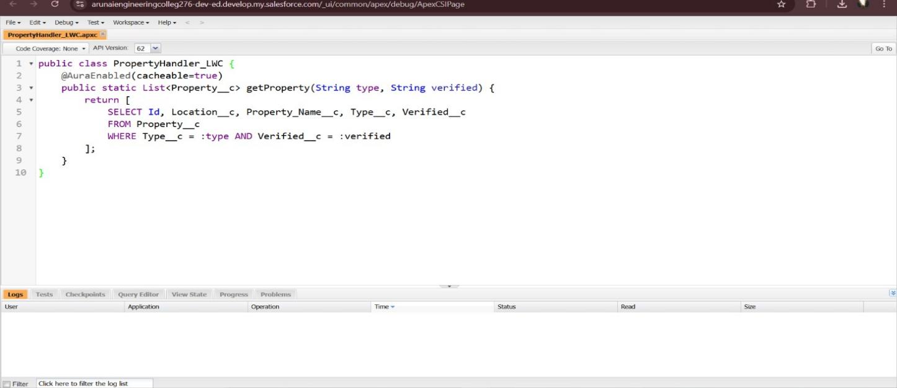





#### Code :-

<template>

<lightning-card>

<div class="slds-box">

<div class="slds-text-align_left">

<h1 style="font-size: 20px;"><b>Properties</b></h1>

</div>

<div>

<div class="slds-grid slds-gutters">

<div class="slds-col slds-size_5-of-6">

<lightning-combobox name="Type" label="Property

Type" value={typevar} placeholder="Select Property type" options={propetyoptions} onchange={changehandler}></lightningcombobox>

</div>

<div class="slds-col slds-size_1-of-6">

<br>

<lightning-button-icon variant="neutral" iconname="standard:search" alternative-text="Search" label="Search" onclick={handleClick}></lightning-button-icon> </div>

</div> </div>

</div>

<template if:true={istrue}>

<div class="slds-box">

<lightning-datatable key-field="id" data={propertylist} columns={columns}></lightningdatatable>

</div>

</template>





<template if:false={isfalse}> <div class="slds-box">

<div style="font-size: 15px;"><b>No properties Are Found !!</b></div>

</div>

</template>

</lightning-card>

</template>

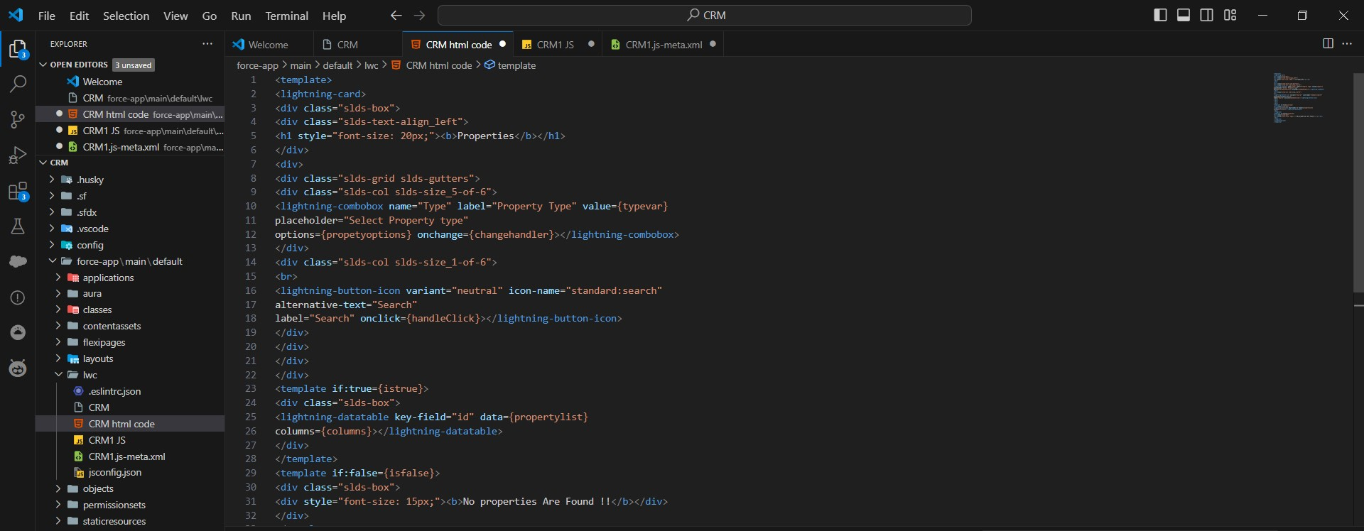



#### 

#### Code :-

import { LightningElement, api, track, wire } from 'lwc'; import getProperty from

"@salesforce/apex/PropertHandler_LWC.getProperty" import { getRecord } from 'lightning/uiRecordApi';

import USER_ID from '@salesforce/user/Id';

#### export default class C_01_Property_Management

extends LightningElement { @api recordId

userId = USER_ID;

@track propertylist = []; columns = [

#### { label: 'Property Name', fieldName: 'Property_Name c' }, { label: 'Property Location', fieldName: 'Location c' },

{ label: 'Property Type', fieldName: 'Type c' },

{ label: "Property link", fieldName: "Property_link c" } ]

propetyoptions = [

#### { label: "Commercial", value: "Commercial" }, { label: "rental", value: "rental" }

{ label: "Residential", value: "Residential" },

]

@wire(getRecord, { recordId: "$userId", fields:

#### ['User.Verified c'] }) recordFunction({ data, error })

{

if (data) { console.log(data)

console.log("This is the User Id ---> "+this.userId); this.verifiedvar = data.fields.Verified c.value;

} else {

#### console.error(err or) console.log('this is error')

}

}



changehandler(event) { console.log(event.target.value); this.typevar = event.target.value; }

handleClick() {

#### getProperty({ type: this.typevar, verified: this.verifiedvar })

.then((result) => { this.isfalse = true; console.log(result)

#### console.log('This is the User id ---> ' + this.userId);

console.log('This is the verified values ---> ' + this.verifiedvar); if (result != null && result.length != 0) { this.istrue = true; this.propertylist = result; console.log(this.veri fiedvar); console.log(this.type var)

} else {

this.isfalse = false; this.istrue = false;

}

#### })

.catch((error) => { console.log(error)

#### })

}

}





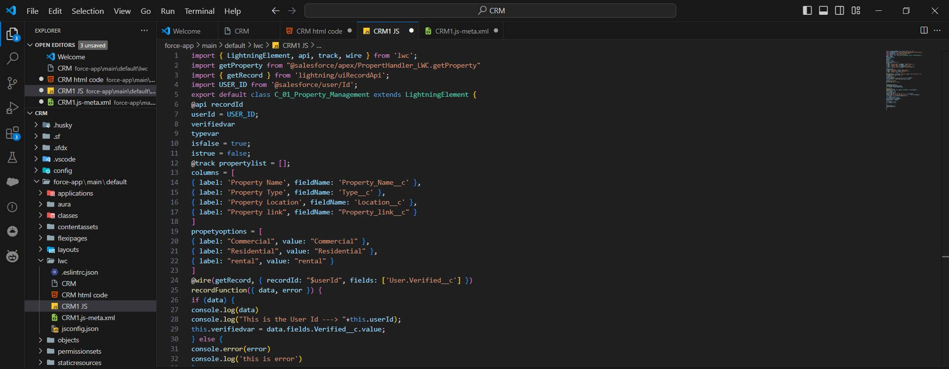

#### 



#### Code :-

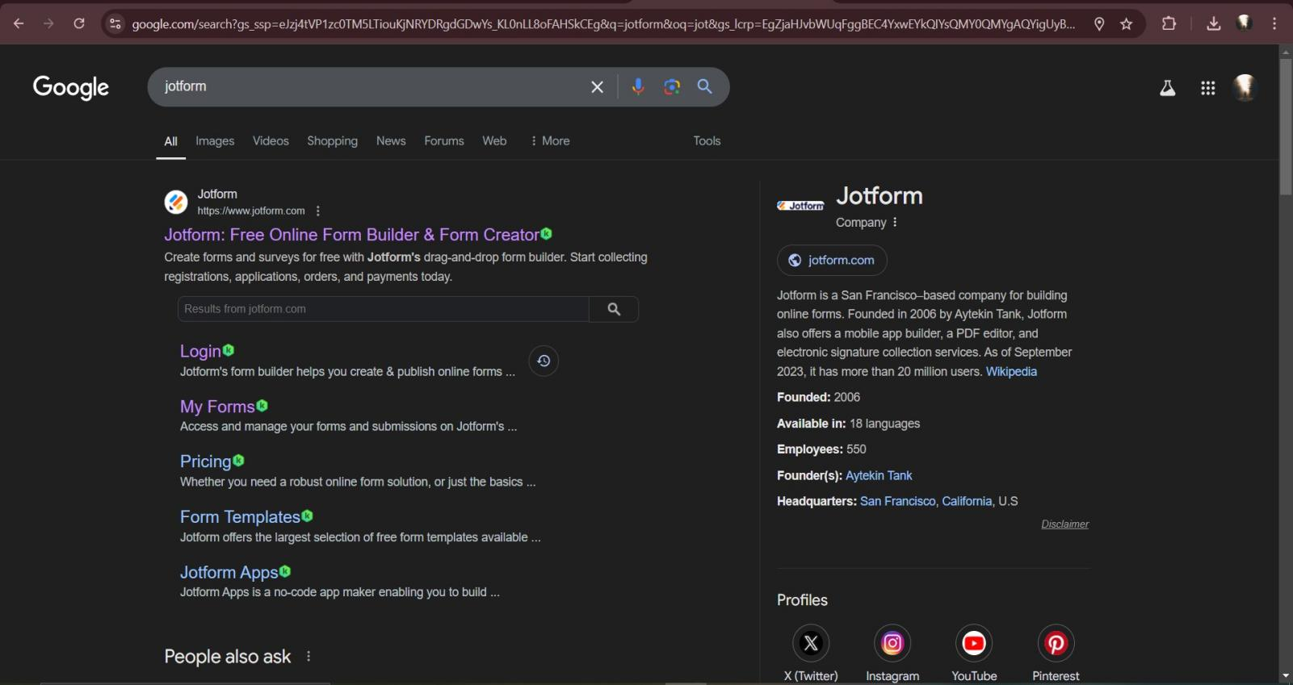

<?xml version="1.0" encoding="UTF-8"?>

<LightningComponentBundle

[xmlns="http://soap.sforce.com/2006/04/metadata">](http://soap.sforce.com/2006/04/metadata)

<apiVersion>59.0</apiVersion>

<isExposed>true</isExposed>

<targets>

<target>lightning RecordPage</target>

<target>lightning AppPage</target>

<target>lightning HomePage</target>

</targets>

</LightningComponentBundle>

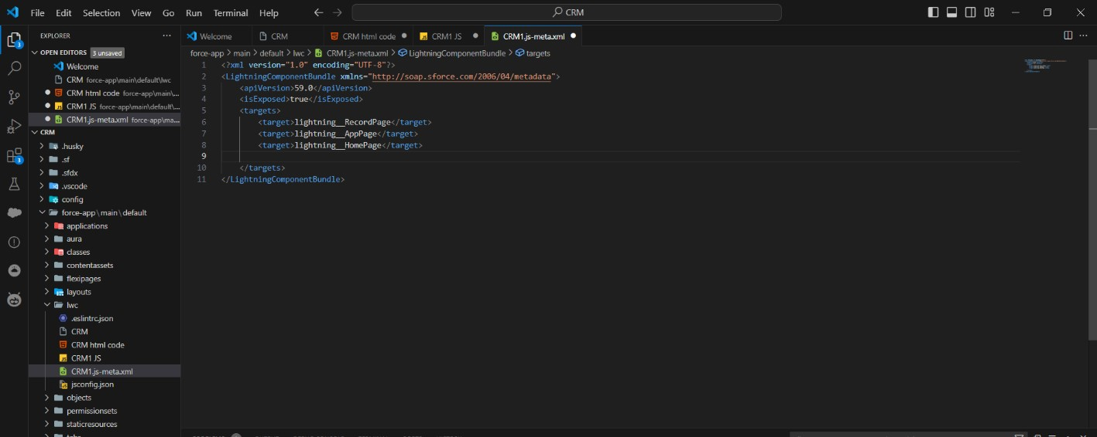





**Conclusion**

The implementation of the CRM Application to handle clients and their property-related requirements has achieved significant milestones in transforming client interaction and property management processes. By centralizing all client and property data within Salesforce CRM, the project has ensured accuracy, consistency, and ease of access. Agents now have the flexibility to access vital information on-the-go through a mobile-friendly application, greatly enhancing their productivity. Routine tasks such as scheduling property viewings and sending follow-up communications have been streamlined through automated processes, resulting in increased operational efficiency. Client engagement has been significantly improved with automated notifications and real-time updates, leading to higher client satisfaction and retention rates.

Moreover, the project has leveraged Salesforce’s advanced analytics and reporting tools to gain insights into client behavior, sales performance, and market trends, facilitating data-driven decision-making. Robust security measures have been implemented to protect sensitive client and property data, ensuring compliance with data protection regulations. Comprehensive tracking of all client-agent interactions has facilitated personalized services and improved relationship management.

Finally, by effectively targeting new client segments and property opportunities through integrated marketing efforts, the project has successfully expanded market reach. Overall, these accomplishments collectively enhance the efficiency, accuracy, and effectiveness of client and property management processes, supporting the long-term goals of real estate businesses and property management organizations.